Wave Function Outputs:
Question 2
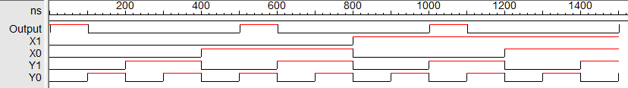
Part c:

Part d:
